zabbix 3 后续版本

{ALERT.SENDTO}

{ALERT.SUBJECT}

{ALERT.MESSAGE}

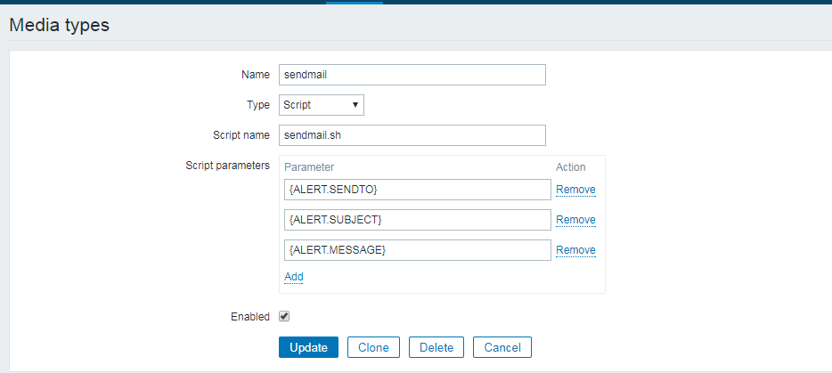

logrt[/zywa/tomcat/logs/catalina.out,"memory leak"]

{[Template Test:logrt[/zywa/tomcat/logs/catalina.out,"memory leak"]](http://jiankong2.zywa.com.cn/items.php?form=update&itemid=28931).**str(**memory leak**)**}=1 and {[Template Test:logrt[/zywa/tomcat/logs/catalina.out,"memory leak"]](http://jiankong2.zywa.com.cn/items.php?form=update&itemid=28931).**nodata(**60**)**}=0

